88

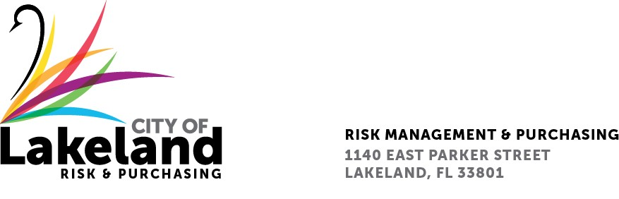

**NOTICE**

**REQUEST FOR PROPOSAL**

**ANNUAL HVAC SERVICE, PARTS AND MAINTENANCE - FOR MCINTOSH, LARSEN AND WINSTON POWER GENERATION FACILITIES**

**for the**

**city OF LAKELAND**

**RFP 2025-RFP-060**

**September 8, 2025**

The City of Lakeland Selection Committee for the above referenced RFP will be meeting on Thursday September 11, 2025, at 10:00 a.m. at **the McIntosh Power Plant 3400 East Lake Parker Dr. Lakeland, FL 33805 (Unit 5 Conference room – 3rd floor ) (ENTER THROUGH GATE 8)**

In accordance with the Americans with Disabilities Act and Section 286.26, Florida Statutes, persons with disabilities needing special accommodation to participate in this proceeding, or those requiring language assistance *(free of charge)* should contact the City of Lakeland ADA Specialist, Kristin Meador , no later than forty-eight (48) hours prior to the proceeding, at (863) 834-8444, Email: kristin.meador@lakelandgov.net  **If hearing impaired**, please contact the **TDD numbers**: Local – (863) 834-8333 or 1-800-955-8771 (TDD-Telecommunications Device for the Deaf) or the **Florida Relay Service** Number 1-800-955-8770 (VOICE), for assistance.