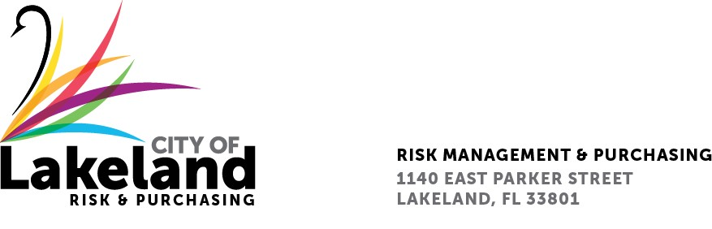

**NOTICE**

**REQUEST FOR QUALIFICATIONS**

**RESIDENT PROJECT REPRESENTATIVE SERVICES FOR THE WESTERN TRUNK SEWER UPGRADES (CCNA)**

**APRIL 7, 2025**

**2025-RFQ-006**

The Selection Committee, for the above referenced RFQ will be meeting on Tuesday, April 8, 2025 from 8:15 a.m. until approximately 11:00 a.m., in the Risk & Purchasing Bid Room, 2nd floor,1140 E. Parker Street, Lakeland, FL 33801. The committee members will be conducting interviews from two (2) firms, pursuant to the above referenced solicitations and other related matters.

**Please note that while this is a publicly noticed open meeting, it will be conducted pursuant to Fla. Stat. 286.0113 (2) (b) 1. And 2. As a result, the presentations will be closed to the public and will be recorded in accordance with Florida statutory requirement. Presentations are scheduled from 8:15 a.m. to 10:00 a.m. The Public meeting will begin at 10:15 a.m.

In accordance with the Americans with Disabilities Act and Section 286.26, Florida Statutes, persons with disabilities needing special accommodation to participate in this proceeding, or those requiring language assistance *(free of charge)* should contact the City of Lakeland ADA Specialist, Kristin Meador, no later than forty-eight (48) hours prior to the proceeding, at (863) 834-8444, Email: [kristin.meador@lakelandgov.net](mailto:kristin.meador@lakelandgov.net).  **If hearing impaired**, please contact the **TDD numbers**: Local – (863) 834-8333 or 1-800-955-8771 (TDD-Telecommunications Device for the Deaf) or the **Florida Relay Service** Number 1-800-955-8770 (VOICE), for assistance.