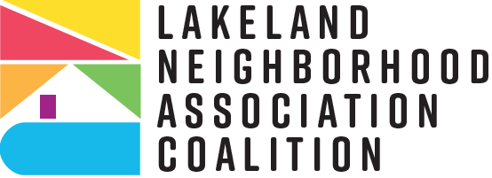
“Love Where You Live”
City of Lakeland Neighborhood Partnership Matching Grant Program Schedule 2025-2026
Please review the following schedule for the Matching Grant Program 2025-2026 application cycle. Please note that although we expect these dates to remain intact as listed, adjustments may occur if circumstances arise that warrant such changes and if so, we will send prompt notification for calendar adjustments.
- February 28th to March 17: Neighborhood Outreach will notify Neighborhood Associations about the upcoming NPMG Mandatory Training
- March 21st (Friday): NPMG Mandatory Training, 1:30-3:30 p.m., the Coleman-Bush Building

- March 21st (if application is live on 3/21) to April 24th: Eligible neighborhood associations may apply for the 2025/2026 grant ONLY IF the NA submitted their last completed grant’s Completion Report (yours may be FY 2023 or FY 2024) on time or as directed.

- March 21st to April 11th (Friday): Application Support from Senior Planner is available through scheduled meetings ONLY (at Senior Planner’s discretion). Use Calendly (link will be provided by March 10th) to schedule a meeting by phone, in person, or via Teams/Zoom for technical assistance with the NPMG application in Neighborly.
- April 24 at 11:59 p.m. (Thursday): Completed 2025-2026 NPMG applications due in Neighborly portal with attached Meeting Minutes & Worksheets (Budget, Contribution, Volunteer).
- April 25 to April 29th: Neighborhood Outreach Senior Planner reviews applications to prepare for committee submission. Eligible applications will be assigned to Grant Review Committee members. Incomplete/late applications will not be submitted to the committee (Senior Planner has sole discretion).
- April 30th-May 16th: Grant Review Committee will score applications
- Early June: Decision letters will be mailed
- October 1, 2025: 2025-2026 NPMG FY begins
- Fall 2025 (Date TBA): Mandatory Grant Writing Workshop; 2025-2026 NPMG Round Two application window opens for eligible applicants
- February 2026 (Date TBA): NPMG Round Two application window closes
- September 30, 2026: All projects MUST be completed
- October 23, 2026: 2025-2026 Grant Completion Reports DUE

