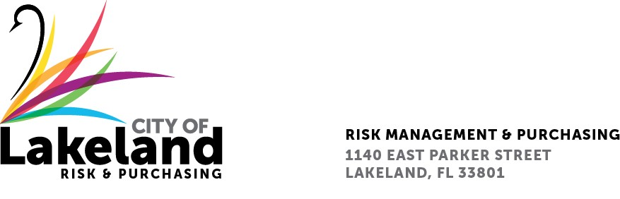

**NOTICE**

**REQUEST FOR PROPOSAL**

**IBM MAXIMO APPLICATION UPGRADE TO MAS 9 AND PLATFORM MIGRATION**

**for the**

**city OF LAKELAND**

**RFP 2024-RFP- 353**

**March 18, 2025**

The Selection Committee, for the above reference RFP will be meeting on Monday March 31, 2025, from 8:30 a.m. until approximately 12:00 p.m., at the City of Lakeland Purchasing Bid Room 2nd Floor located at 1140 East Parker St Lakeland, FL 33801. The committee members will be conducting interviews from two (2) firms, pursuant to the above-mentioned solicitations and other related matters.

**Please note that while this is a publicly noticed open meeting, it will be conducted pursuant to Fla. Stat. 286.0113 (2) (b) 1. And 2. As a result, the presentations will be closed to the public and will be recorded in accordance with Florida statutory requirement. Presentations are scheduled from 8:30 a.m. to 10:45 a.m. The Public meeting will begin at 11:00 a.m.

In accordance with the Americans with Disabilities Act and Section 286.26, Florida Statutes, persons with disabilities needing special accommodation to participate in this proceeding, or those requiring language assistance *(free of charge)* should contact the City of Lakeland ADA Specialist, Kristin Meador , no later than forty-eight (48) hours prior to the proceeding, at (863) 834-8444, Email: kristin.meador@lakelandgov.net  **If hearing impaired**, please contact the **TDD numbers**: Local – (863) 834-8333 or 1-800-955-8771 (TDD-Telecommunications Device for the Deaf) or the **Florida Relay Service** Number 1-800-955-8770 (VOICE), for assistance.