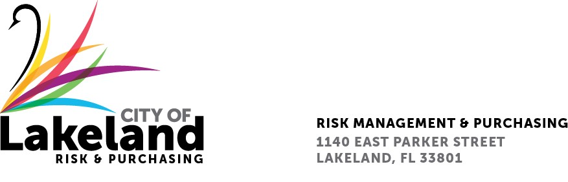

**NOTICE**

**REQUEST FOR QUALIFICATIONS**

**CONSTRUCTION TRADE PROFESSIONALS FOR CONTINUING CONTRACT**

**for the**

**city OF LAKELAND**

**RFQ 2024-RFQ-289**

**September 18, 2024**

The City of Lakeland Selection Committee for the above referenced RFQ will be meeting on Monday September 23rd at 4:00 p.m. at the Lakeland Linder International Airport 2nd Floor Conference Rm Airport A located at 3900 Don Emerson Drive Lakeland, FL 33811

In accordance with the Americans with Disabilities Act and Section 286.26, Florida Statutes, persons with disabilities needing special accommodation to participate in this proceeding, or those requiring language assistance *(free of charge)* should contact the City of Lakeland ADA Specialist, Kristin Meador , no later than forty-eight (48) hours prior to the proceeding, at (863) 834-8444, Email: kristin.meador@lakelandgov.net  **If hearing impaired**, please contact the **TDD numbers**: Local – (863) 834-8333 or 1-800-955-8771 (TDD-Telecommunications Device for the Deaf) or the **Florida Relay Service** Number 1-800-955-8770 (VOICE), for assistance.