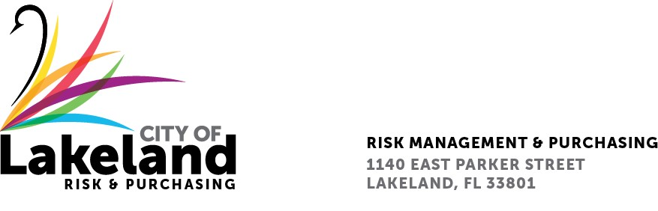

**NOTICE**

**REQUEST FOR QUALIFICATIONS**

**PROFESSIONAL MUNICIPAL ENGINEERING SERVICES (CCNA) FOR STATE ROAD 37 FROM ARIANA STREET TO LIME STREET**

**for the**

**city OF LAKELAND**

**RFQ 2024-RFQ- 277**

**September 1, 2024**

The City of Lakeland Selection Committee for the above referenced RFQ will be meeting on Wednesday September 4 at 3:00 p.m. at the City of Lakeland Purchasing Bid Room 2nd Floor located at 1140 East Parker St Lakeland, FL 33801

In accordance with the Americans with Disabilities Act and Section 286.26, Florida Statutes, persons with disabilities needing special accommodation to participate in this proceeding, or those requiring language assistance *(free of charge)* should contact the City of Lakeland ADA Specialist, Kristin Meador , no later than forty-eight (48) hours prior to the proceeding, at (863) 834-8444, Email: kristin.meador@lakelandgov.net  **If hearing impaired**, please contact the **TDD numbers**: Local – (863) 834-8333 or 1-800-955-8771 (TDD-Telecommunications Device for the Deaf) or the **Florida Relay Service** Number 1-800-955-8770 (VOICE), for assistance.