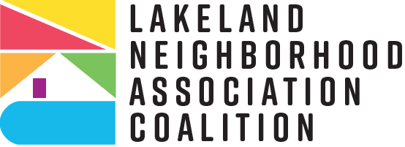
“Love Where You Live”
City of Lakeland Neighborhood Partnership Matching Grant Program Schedule 2024-2025
Please review the following schedule for the Matching Grant Program 2024-2025 cycle. Please note that although we expect these dates to remain intact as listed, adjustments may occur if circumstances arise that warrant such changes and if so, we will send prompt notification for calendar adjustments.
- May 21st to June 7th-Neighborhood Outreach will notify Neighborhood Associations about the upcoming Technical Assistance Meeting
- June 11th (Tuesday)-Mandatory Technical Assistance Meeting, 1-3 p.m., the Coleman-Bush Building, Room B
- June 12th (Wednesday)-Application opens in Neighborly at 6 a.m.
*Neighborly application updates were delayed, likely available week of June 17 (or 24th at latest).
- Updated: Week of June 24th to July 25th (Thursday) Staff Support Period: Set up one on one TA meetings: phone, in person, or via Teams/Zoom for assistance with applications. Email questions to group email for responses & other applicants with similar questions/concerns can get answers, too.
- August 6th (Tuesday)-Application submissions due at 4:59 p.m.
- August 7th (Wednesday) to August 21st (Wednesday)-Staff review of applications/vetting submissions to prepare for committee submission.
- August 22 (Thursday) to September 6th (Friday)-Grant Review Committee makes final selections for grant awards
- Early October-Grant awards will be announced

