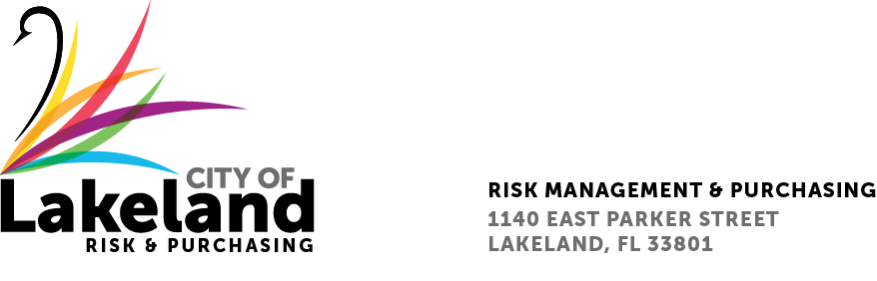

NOTIFICATION OF INTENT TO AWARD

June 20, 2023

Reference: R.F.Q. No. 2023-RFQ-020

Titled: Professional Engineering & Environmental Consulting Services (CCNA) for the Lake Bonnet Drainage Basin Flood Hazard and Debris Mitigation Project

The Selection Committee Members met on Monday, June 19, 2023, to review and discuss the submittals we received from the Respondents. The final rankings were as follows:

- AECOM Technical Services Inc
- Geosyntec Consultants Inc
- Environmental Science Associates Inc
- HGS LLC dba RES Environmental Operating Co LLC

The City intends to begin contract negotiations with the highest-ranked firm upon City Commission Approval. The City of Lakeland would like to thank you for the time and effort that you expended by being involved with our Request for Qualifications process.

Sincerely,

Tara T. Walls

Tara T. Walls, CPPB
Senior Purchasing Agent

Cc: Lana Braddy
File

