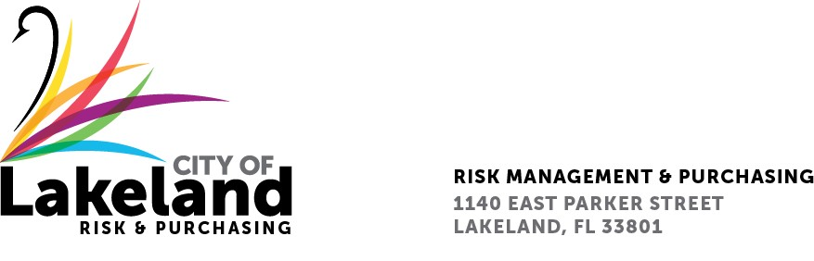

NOTICE

REQUEST FOR PROPOSAL

CALL CENTER INTEGRATED VOICE RESPONSE (IVR) SYSTEM

FOR LAKELAND ELCTRIC
for the
city OF LAKELAND

RFP 2024-RFP- 220

May 16, 2024
The City of Lakeland Selection Committee for the above referenced RFP will be meeting on Thursday May 23, at 2:00 p.m. at the City of Lakeland Purchasing Bid Room 2nd Floor located at 1140 East Parker St Lakeland, FL 33801

In accordance with the Americans with Disabilities Act and Section 286.26, Florida Statutes, persons with disabilities needing special accommodation to participate in this proceeding, or those requiring language assistance (free of charge) should contact the City of Lakeland ADA Specialist, Kristin Meador , no later than forty-eight (48) hours prior to the proceeding, at (863) 834-8444, Email: kristin.meador@lakelandgov.net If hearing impaired, please contact the TDD numbers: Local – (863) 834-8333 or 1-800-955-8771 (TDD-Telecommunications Device for the Deaf) or the Florida Relay Service Number 1-800-955-8770 (VOICE), for assistance.

