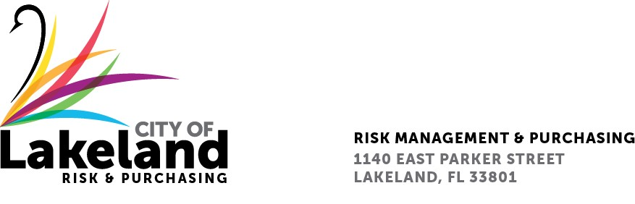

NOTICE

REQUEST FOR QUALIFICATION

DESIGN AND OVERSIGHT OF THE CONSOLIDATED FUEL FARM PROJECT AT LAKELAND LINDER INTERNATIONAL AIRPORT (CCNA)
for the
city OF LAKELAND

RFQ 2024-RFQ- 231

May 10, 2024
The City of Lakeland Selection Committee for the above referenced RFQ will be meeting on Friday May 17, 2024. at 3:00 p.m. at the Lakeland Linder International Airport 3900 Don Emerson Dr. Ste. 210 Lakeland, FL 33811

In accordance with the Americans with Disabilities Act and Section 286.26, Florida Statutes, persons with disabilities needing special accommodation to participate in this proceeding, or those requiring language assistance (free of charge) should contact the City of Lakeland ADA Specialist, Kristin Meador , no later than forty-eight (48) hours prior to the proceeding, at (863) 834-8444, Email: kristin.meador@lakelandgov.net If hearing impaired, please contact the TDD numbers: Local – (863) 834-8333 or 1-800-955-8771 (TDD-Telecommunications Device for the Deaf) or the Florida Relay Service Number 1-800-955-8770 (VOICE), for assistance.

